Award
To VFW Post 12043
Halloween Pumpkin Walk
Maricopa, Arizona
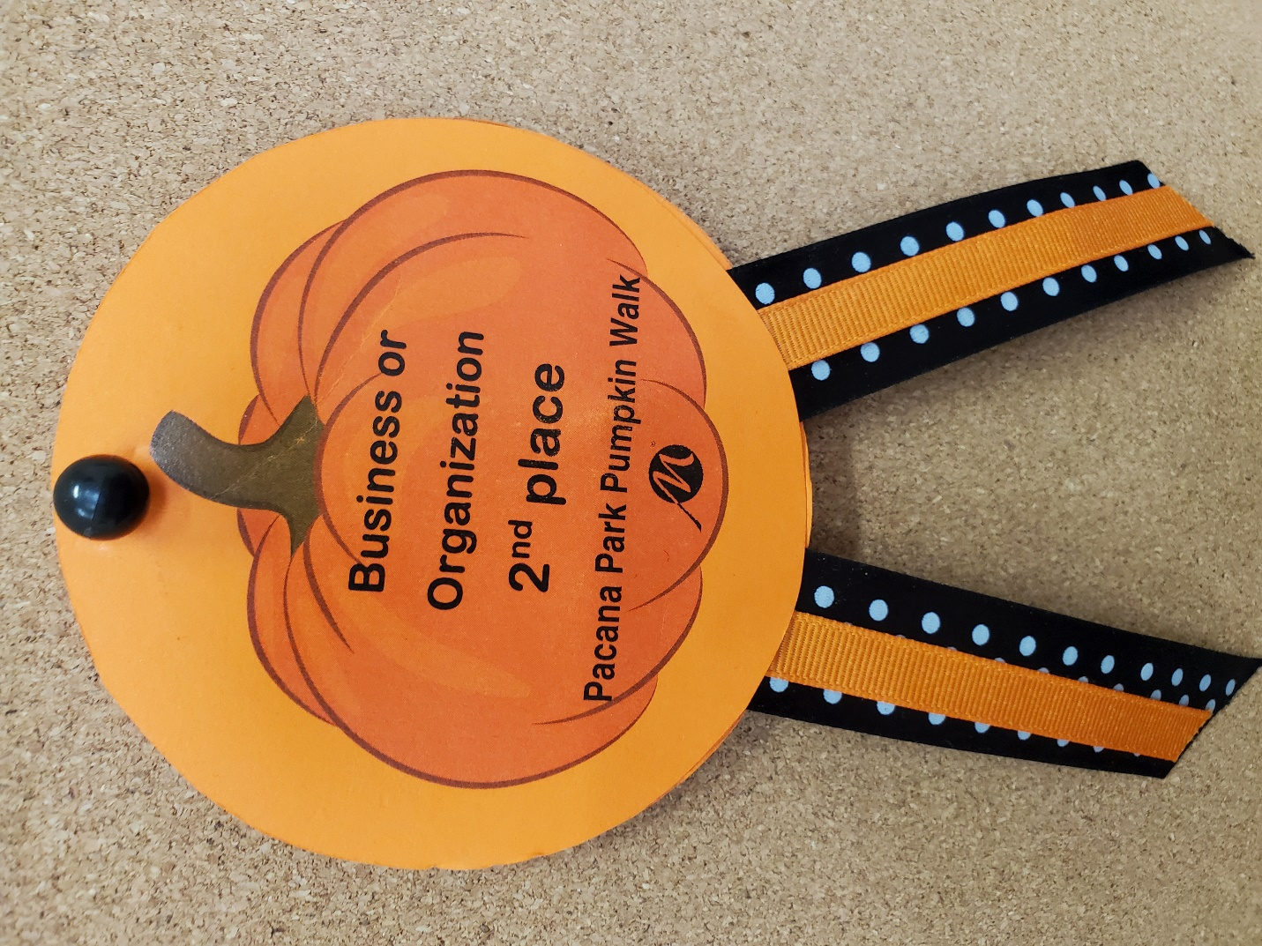

October 26, 2022

